SPH3U: Energy Consumption and Climate Change
Recorder: __________________
Manager: __________________
Speaker: _________________
0 1 2 3 4 5

Climate change is one of the greatest challenges facing human beings over the next fifty years. The Earth’s climate is changing due to humans adding greenhouse gases to the atmosphere that trap heat energy from the sun. Increasing temperatures will disrupt societies around the world as weather patterns shift and sea levels rise. Shifting water and land resources will result in large scale movements of people that create tremendous political challenges and increase the likelihood of conflict.

A: Canada’s Greenhouse Gas Emissions
Every year Canada contributes as much greenhouse gas emissions to the atmosphere as the entire continent of Africa. The graph below shows Canada’s emissions by economic sector during a 24 year period. Take a moment to read over the graph.

Greenhouse gas emissions by economic sector, Canada, 1990 to 2014
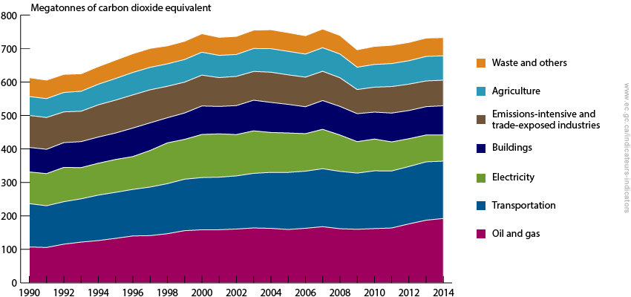
(source: https://www.ec.gc.ca/indicateurs-indicators/default.asp?lang=en&n=F60DB708-1)

- Interpret. This type of graph is a stacked graph. To read it, choose a trend line and measure downwards to the next trend line. That vertical distance gives the value for that year. For example, what are the emissions for the buildings sector in 1990 in units of kg? Show your work. (1 tonne = 1000 kg, 1 megatonne = 10⁶ kg).

- Interpret. Which sectors of Canada’s economy are noticeably decreasing emissions and which are increasing? Which are roughly the same?

- Reason. Which sector’s emissions do you think York Mills students and their families make the greatest contribution to? Explain.

Transportation sector greenhouse gas emissions, Canada, 1990 to 2014
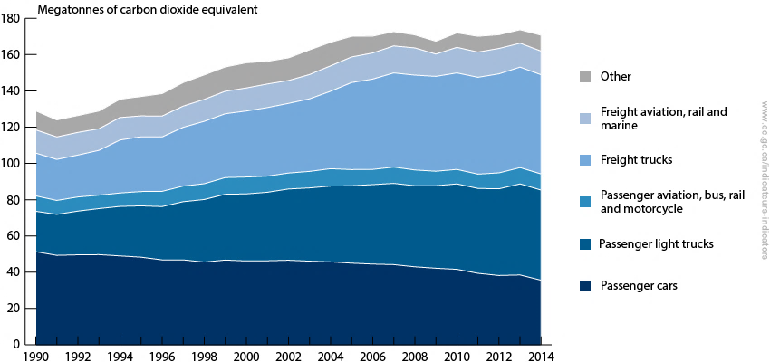
(source: https://www.ec.gc.ca/indicateurs-indicators/default.asp?lang=en&n=F60DB708-1)

- Interpret. The graph for the transportation sector shows the emissions breakdown by type of vehicle and purpose of use. You and your family are most directly responsible for passenger car use and emissions. Describe the trend in the data.

- Interpret. Does this represent the full story? It might help to know that the category of “light trucks” includes vans, pick-up trucks, and sports utility vehicles. With this in mind, how is Canada doing with emissions by passenger vehicles that people or families own?

- Calculate. It is also helpful to know that the population in Canada in 1990 was 27.79 million and its population in 2014 was 35.54 million people. “Per capita” means per person. Has Canada’s per capita GHG emissions for passenger transportation improved over the 24 year timespan?

- Reason. To help Canada meet its Paris Accord GHG emission targets, we want to focus on reducing passenger vehicle emissions. What characteristics of a car or light truck could be changed that would help to reduce that vehicle’s GHG emissions?

SPH3U: The Green Vehicle Challenge

You are a part of a team of experts whose job is to create an improved, energy efficient vehicle that will help reduce greenhouse gas emissions. To do this, your team will work through a process where you design, build, and improve your vehicle, measure its performance, and assess its environmental impact. As professionals working in a demanding industry, you will document all your work carefully.

Project Outline

The project consists of four phases. The design and test phases are completed three times as you improve your vehicle.

Design Phase
- Document your design ideas. Build or modify your car.
Design Phase × 3
Environmental Analysis
Test Phase × 3
- First Time: Build your car based on the given designs.
- Second Time: Study the performance criteria and your test results to devise improvements.
- Third Time: Visit every other team in the class to look for interesting ideas. Devise very interesting or creative changes to try out for your final design.
Test Phase
- Choose two laboratory tests to measure performance against criteria. Make sure all criteria are tested by the third cycle. Report the results.
- After First and Second Time: Return to design phase
- After Third Time: Proceed to the environmental analysis
Environmental Analysis
- Conduct laboratory tests to measure energy efficiency, vehicle performance, fuel costs, and greenhouse gas emissions

Materials

- Use the materials provided in class or other materials that can be found in the classroom.
- At the end, disassemble your car and neatly return any re-useable materials.

Performance Criteria

Goal: Satisfy as many performance criteria as possible. As you repeat the design phase, improve your vehicle and help it meet more criteria. It is not expected that your vehicle will meet all the criteria.

Empty weight | Test 1: Maximum Distance | Test 2:  Top Speed | Test 3: Rolling Friction (detach the elastic) | Test 4: Path Deviation
Less than 250 g | At least 6 m in one attempt | At least 1.5 m/s at one time | Less than 0.03 N | Less than 15 cm after 1 m

Final Report

Your team should submit one final report that includes:
- 1 title page
- 3 design pages
- 3 test pages
- 1 environmental analysis
- 1 green vehicle evaluation page with student evaluations recorded
Your report should be submitted in a neat and professional manner.

Team Work

Group Roles: Take turns performing each role.
- Writer: Each page of the report should be written by only one person (the other group members will provide ideas). The report pages must be written in pencil. When finished, the writer will sign off on the page.
- Checker: Use the rubrics to check the page. Use a different coloured pen and check mark the high-quality work and write in any improvements or corrections. Sign the page, certifying that it is high-quality, reliable work.
- Evaluator: Use the rubrics to provide a numerical evaluation of the quality of the work at the bottom of the page.

Share the work
- Each person should do roughly the same amount of work overall on the various pages of the report.
- Take turns completing the different parts of the report. Each person should complete one design page and one test page.

Advice for the Checker: When you sign off on the work, you are in effect saying, “if there is a serious problem with this work, I would accept the consequences for my team”. In the working world, the consequences can range from a stern “talking-to”, to being fired, or even being criminally prosecuted. Faulty or poor-quality work often affects the lives of other people in ways that range from a minor inconvenience, to physical injury or death. The success of your future work career depends on the quality of each and every task you perform, especially the most recent one.

Project Evaluation

The final report for your project will be evaluated based on two criteria:

Criteria | Inadequate: Poor | Adequate: OK | Excellent: Wow!
Agreement:  Teacher evaluations matches student evaluations | 0 – 5: many student evaluations are very different from the teacher’s | 6 – 8: many student evaluations are pretty close to the teacher’s | 9-10: most student evaluations agree with the teacher’s
Quality:  Physics ideas and techniques are used and communicated clearly. A professional product. | 0 – 5: Messy, missing or confusing work. Physics ideas are poorly understood or applied. | 6 – 8: Clear, well-organized work. Physics ideas are used and applied appropriately. Some minor mistakes in understanding or communication are present. | 9 – 10: Work is very clear, easy to follow and understand. Physics ideas are used appropriately and thoughtfully. Any mistakes are very minor or superficial.

Test Page # ______ Date:

Weight:

Test 1: Distance / Top Speed / Rolling Friction / Path Deviation (circle one)
Procedure:

Data, Calculations, and Results:

Performance Criteria Met?

Test 2: Distance / Top Speed / Rolling Friction / Path Deviation (circle one)
Procedure:

Data, Calculations, and Results:

Performance Criteria Met?

Prepared by: _______________________________ Checked by: __________________________________
Evaluated by:___________________________ Reliability: 1 2 3 4 5 Clarity: 1 2 3 4 5 6 7 8 9 10

Design Page # _________ Date:

Goals:

Diagrams:
Descriptions:

Prepared by: _______________________________ Checked by: __________________________________
Evaluated by: ____________________ Goals: 1 2 3 4 5 Diagrams: 1 2 3 4 5 6 7 8 9 10 Descriptions: 1 2 3 4 5

Design Page # _________ Date:

Goals:

Diagrams:
Descriptions:

Prepared by: _______________________________ Checked by: __________________________________
Evaluated by: ____________________ Goals: 1 2 3 4 5 Diagrams: 1 2 3 4 5 6 7 8 9 10 Descriptions: 1 2 3 4 5

Test Page # ______ Date:

Weight:

Test 1: Distance / Top Speed / Rolling Friction / Path Deviation (circle one)
Procedure:

Data, Calculations, and Results:

Performance Criteria Met?

Test 2: Distance / Top Speed / Rolling Friction / Path Deviation (circle one)
Procedure:

Data, Calculations, and Results:

Performance Criteria Met?

Prepared by: _______________________________ Checked by: __________________________________
Evaluated by:___________________________ Reliability: 1 2 3 4 5 Clarity: 1 2 3 4 5 6 7 8 9 10

Test Page # ______ Date:

Weight:

Test 1: Distance / Top Speed / Rolling Friction / Path Deviation (circle one)
Procedure:

Data, Calculations, and Results:

Performance Criteria Met?

Test 2: Distance / Top Speed / Rolling Friction / Path Deviation (circle one)
Procedure:

Data, Calculations, and Results:

Performance Criteria Met?

Prepared by: _______________________________ Checked by: __________________________________
Evaluated by:___________________________ Reliability: 1 2 3 4 5 Clarity: 1 2 3 4 5 6 7 8 9 10

Design Page Rubric

The design pages should have enough detail that another team could take your car, follow your design page, easily build the car or make the appropriate changes, and understand why the changes are being made.

Criteria | Inadequate: Poor | Adequate: OK | Excellent: Wow!
Goals: explaining the purpose | 0 – 2: Missing or unclear, rushed, not helpful for another group | 3 – 4: Goals reference the design criteria or previous test results | 5: Goals are carefully explained and reference design criteria or previous test results, neatly written, very easy to read
Diagrams: careful drawings | 0 – 5: Messy, missing measurements and labels, unclear, very difficult for another group to use | 6 – 8: Clear drawings, labels and measurements, minor details could be improved, OK for another group to follow | 9 – 10: Neat, clear drawings. Multiple perspectives used. Labels and measurements are clear. Very easy for another group to use.
Descriptions: construction details | 0 – 2: Missing or unclear, rushed, not helpful for another group | 3 – 4: Ideas/changes are described and choices justified, OK for another group to follow | 5: Construction ideas and changes are carefully described. Design choices are justified using ideas that relate to physics concepts. Very easy for another group to follow

The Test Page Rubric

Your test procedures should be clear and precise such that another group could take your vehicle, follow your procedures, and get very similar results within your measurement uncertainty.

 | Inadequate: Poor | Adequate: OK | Excellent: Wow!
Reliability:  clear procedures and data | 0 – 2: Results are unsure, faulty procedure, no uncertainties, too little data | 3 – 4: Procedure adequate, minor details unclear. Connections to ideas from class are apparent. | 5: Thoughtful, clear procedure. Connections to physics ideas are clearly stated. Easy to reproduce measurements. Enough data to average-out random variations in measurements. Measurement uncertainties included.
Clarity:  data and calculations clear | 0 – 5: Messy, poor organization, unreliable work, no physics diagrams used | 6 – 8: Data recorded, calculation steps clear, results shown, work follows standards from class, attempts to use physics diagrams, minor errors or omissions with diagrams or calculations | 9 – 10: Data carefully recorded, calculation steps easy to follow, all important details are present, physics diagrams are used accurately, easy to read

The Environmental Analysis Rubric

The purpose of the analysis is to determine the energy efficiency of your vehicle and provide a reliable projection for the GHG emissions due to the production of your vehicle and its operation over its lifetime.

 | Inadequate: Poor | Adequate: OK | Excellent: Wow!
Clarity:  data and calculations clear | 0 – 5: Messy, poor organization, unreliable work, no physics diagrams used | 6 – 8: Data recorded, calculation steps clear, results shown, work follows standards from class, attempts to use physics diagrams, minor errors or omissions with diagrams or calculations | 9 – 10: Data carefully recorded, calculation steps easy to follow, all important details are present, physics diagrams are used accurately, easy to read

Environmental Analysis Procedures

Energy input, output, and efficiency | Follow the instructions (turn page over) to measure the amount of energy that is input (E₁) and output (E₂) from your vehicle’s elastic when it is stretched to its test length, similar to how it is wound up in your vehicle during the design phase tests.  - Calculate the energy output (E₂) from the elastic: E₂ = E₁- E_{th}.  - Calculate the efficiency: Eff = E₂ / E₁.  - Use physics diagrams to show the energy transfer.
Speed and distance performance ratings | - Use the energy output to calculate a fastest possible speed for your vehicle (v_{max}). This assumes that all the energy output by the elastic is transferred to kinetic energy.  - Use the most recent rolling friction measurement to calculate a farthest possible distance (Δx_{max}) your vehicle can travel.  - Calculate a speed performance rating and distance performance rating using your measured values from the most recent test and your predicted values. (performance rating = actual value / predicted value)
Lifetime fuel use and cost | - Use the Lifetime Vehicle Use chart to calculate the fuel consumption (FC) for your vehicle using your efficiency result.  - Calculate the total amount of gasoline your vehicle will use on average over its lifetime.  - Calculate the lifetime cost of the fuel using 2017 dollars and gasoline prices.
GHG emissions due to manufacture | The physical construction of your real-life vehicle (made of steel, plastic, rubber, etc.) will release greenhouse gases (GHGs) into the atmosphere.  - Calculate the total amount of GHGs released due to the construction of your vehicle. Show the breakdown of your calculation.
Total GHG emissions | - Calculate the lifetime GHG emissions of your vehicle due to fuel consumption.  - Calculate the total lifetime GHG emissions of your vehicle (total lifetime GHG emission = construction GHG emissions + fuel consumption GHG emissions)  - Report the final result in kilograms and metric tonnes (1 t = 1000 kg)

Lifetime Vehicle Use Analysis
Distance Traveled (km) | Fuel consumption/100 km | Fuel Cost/L (2017 prices) | GHG/km
244840 | 8.9 L* (0.7 / Eff)*(F_{f} / 0.02 N) | $1.17 | 95 g * (1.5 - Eff)

Material and Production Analysis
The manufacture of your vehicle will require materials and energy, which contributes to greenhouse gas emissions.
Component | Actual Material | unit | Car - GHG emission per unit | Light Truck - GHG emission per unit
Structural steel frame | Plastic plates | per plate | 2000 kg | 3000 kg
Structural steel struts | Wooden dowel | per cm of dowel | 50 kg | 80 kg
Wheel | Plastic wheel | per wheel | 30 kg | 50 kg
Tire | Rubber band | per rubber band | 15 kg | 25 kg
Engine | Rubber band | per 0.1 g of rubber band | 40 kg | 70 kg
Body panel | Paper | per cm² | 10 kg | 15 kg

Environmental Analysis Date:

Energy Input, Output, and Efficiency

Speed and Distance Performance Ratings

Vehicle Lifetime Fuel Use and Costs

GHG Gas Emissions from Manufacturing
Material | Quantity | kg GHG
Structural steel frame
Structural steel struts
Wheel
Tire
Engine
Body panel

Total GHG emission from manufacturing: _______________

Vehicle Lifetime GHG Emissions

Prepared by: _______________________________ Checked by: __________________________________
Evaluated by: _______________________________ Clarity: 1 2 3 4 5 6 7 8 9 10

Energy Measurement Instructions

The procedures for the environmental analysis are carefully regulated to ensure each design group performs the tests in the same way. Failure to follow the procedures can lead to invalid results that will affect the success of your vehicle and can even lead to lawsuits – just ask Volkswagen!

- Remove your elastic from your vehicle and use the energy measurement equipment. If your vehicle uses multiple elastics, try to use the combination of elastics during the analysis the same way they are used in the vehicle. The equipment will measure the position of your hand and the force in the elastic. It uses these measurements to calculate energy.

- Use the equipment to stretch the elastic from its relaxed length to its stretched length. Energy is being stored in the elastic.

- Allow the elastic to slowly return to its relaxed length. Energy is transferred out of the elastic.

- The computer creates a graph showing the energy changes. The lowest line represents the amount of energy used to stretch the elastic. When you slowly relax the elastic, a second higher line is created. The vertical difference between the lines at any amount of stretch gives the amount of thermal energy lost. 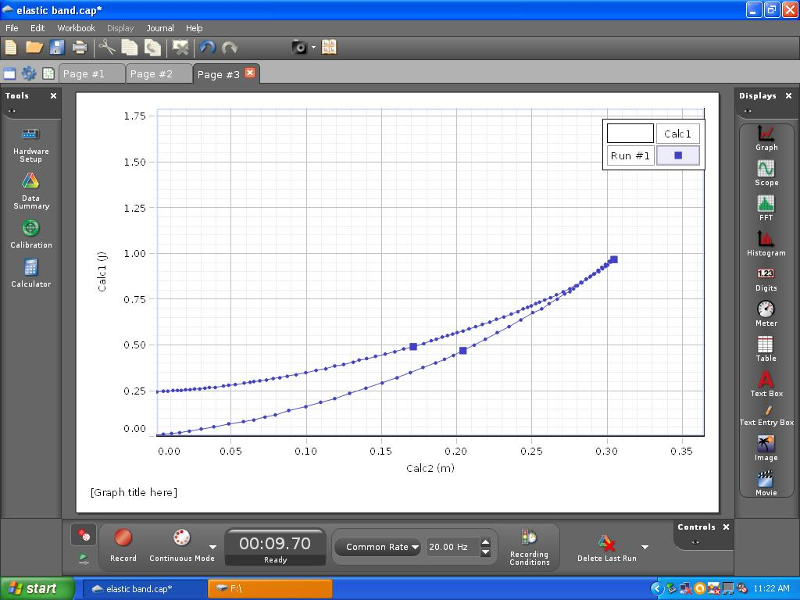
Energy (J)
Stretch (m)
The amount of energy used to stretch the elastic 30.5 cm
The amount of thermal energy loss after the elastic returns to zero stretch

- Use the data from the graph to determine the total energy input to stretch the elastic (the energy input, E₁) and the total thermal energy after the elastic is completely relaxed (the energy loss, E_{th}).

Green Vehicle Project Evaluation Names:

Criteria | Inadequate: Poor | Adequate: OK | Excellent: Wow!
Agreement:  Teacher evaluations matches student evaluations | 0 – 5: many student evaluations are very different from the teacher’s | 6 – 8: many student evaluations are pretty close to the teacher’s | 9-10: most student evaluations agree with the teacher’s
Quality:  Physics ideas and techniques are used and communicated clearly. A professional product. | 0 – 5: Messy, missing or confusing work. Physics ideas are poorly understood or applied. | 6 – 8: Clear, well-organized work. Physics ideas are used and applied appropriately. Some minor mistakes in understanding or communication are present. | 9 – 10: Work is very clear, easy to follow and understand. Physics ideas are used appropriately and thoughtfully. Any mistakes are very minor or superficial.

Total Mark: __________ / 20

Design Pages Feedback

Criteria | Inadequate: Poor | Adequate: OK | Excellent: Wow!
Goals: explaining the purpose | 0 – 2: Missing or unclear, rushed, not helpful for another group | 3 – 4: Goals reference the design criteria or previous test results | 5: Goals are carefully explained and reference design criteria or previous test results, neatly written, very easy to read
Student evaluations
Diagrams: careful drawings | 0 – 5: Messy, missing measurements and labels, unclear, very difficult for another group to use | 6 – 8: Clear drawings, labels and measurements, minor details could be improved, OK for another group to follow | 9 – 10: Neat, clear drawings. Multiple perspectives used. Labels and measurements are clear. Very easy for another group to use.
Student evaluations
Descriptions: construction details | 0 – 2: Missing or unclear, rushed, not helpful for another group | 3 – 4: Ideas/changes are described and choices justified, OK for another group to follow | 5: Construction ideas and changes are carefully described. Design choices are justified. Very easy for another group to follow
Student evaluations

The Test Pages Feedback

 | Inadequate: Poor |  | Adequate: OK | Excellent: Wow!
Reliability:  clear procedures and data | 0 – 2: Results are unsure, faulty procedure, no uncertainties, too little data |  | 3 – 4: Procedure adequate, minor details unclear | 5: Thoughtful, clear procedure. Easy to reproduce measurements. Enough data to average-out random variations in measurements. Measurement uncertainties included.
Student evaluations
Clarity:  data and calculations clear | 0 – 5: Messy, poor organization, unreliable work, no physics diagrams used | 6 – 8: Data recorded, calculation steps clear, results shown, work follows standards from class, attempts to use physics diagrams, minor errors or omissions with diagrams or calculations |  |  | 9 – 10: Data carefully recorded, calculation steps easy to follow, all important details are present, physics diagrams are used accurately, easy to read
Student evaluations

The Environmental Analysis Feedback

 | Inadequate: Poor | Adequate: OK | Excellent: Wow!
Clarity:  data and calculations clear | 0 – 5: Messy, poor organization, unreliable work, no physics diagrams used | 6 – 8: Data recorded, calculation steps clear, results shown, work follows standards from class, attempts to use physics diagrams, minor errors or omissions with diagrams or calculations | 9 – 10: Data carefully recorded, calculation steps easy to follow, all important details are present, physics diagrams are used accurately, easy to read
Student evaluations

